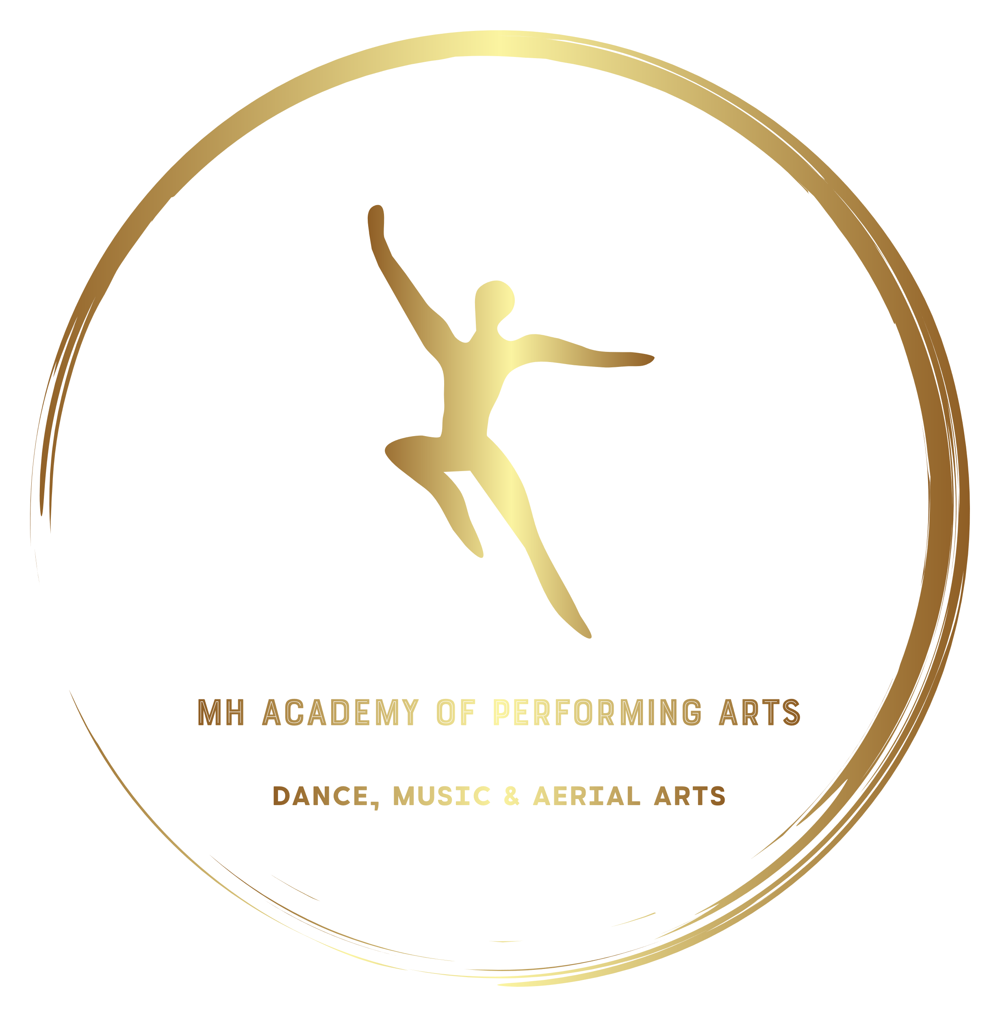

COSTUMES POLICY

Costumes will be required for School Pantomimes, Galas, Troupes and Theatre Company Productions. They will also be required for Solos and competition entries in general.
To maintain a professional image and to effectively dress any entry/ production this policy must be followed and teacher discretion is encouraged when putting costumes together.
- Direction for costumes to be purchased
Your teacher will let you know what things need to be bought for costumes that are appropriate for what we are doing at the time.
MH Academy closed Facebook Group & Microsoft Teams will be used to communicate costume needs as well as directions on where to purchase products such as eBay, Amazon, Primark etc.
- Blind Purchasing
It is discouraged that you buy things that you think might work, as they may not fit in with what choreography is being used the tone of the music etc. we don’t want you to spend unnecessary money so it is advisable you take a picture and message staff or show it to a staff member at your next lesson so you don’t waste money.
- Costumes being made
Some costumes may not be able to be purchased and will need to be made. In these instances, a dress maker will be appointed who is design and make the costume, the cost of which must be covered by the student.
- Selling on your costume
As the student grows older solos will be replaced and more complex choreography or appropriate songs will be used, this will mean a new costume. This means your previous solo will be given to a different student and as such you can then sell your costume to that student (or give it away) to recover some of your expenses.
- School costumes
In some instances, the school will cover the cost of your costume, for example if they are hired, or made for a specific troupe and are purchased out of the school funds.
In these instances, the costume remains the property of the school and it is loaned to the student until a time it is deemed necessary to return it. Failure to return the costume when asked to do so may result in a charge to cover the cost of a replacement.
School Costumes must also be returned in a clean and well-maintained condition as costs of having it cleaned/ repaired may also be passed on to the previous user of the costume.
We are fully aware of how expensive costumes are especially at times of productions and when you have many solos/ troupes to participate in. as a result we will always look to costume our work as cost effectively as possible and when it comes to costumes being made we will always use a reputable seamstress who is reasonably priced.
Students/ Parents can always sign up to our costume savers club where you pay a small amount in each week and when costumes are required we take the funds directly from what you have saved. Please note any shortfall in these funds will be requested from the saver prior to purchase.

I confirm that I have seen and agree to the condition set out by this policy.

Signed: …………………………………………………………………………………

Print: …………………………………………………………………………………….

Date: …………………………………………………………………………………….

