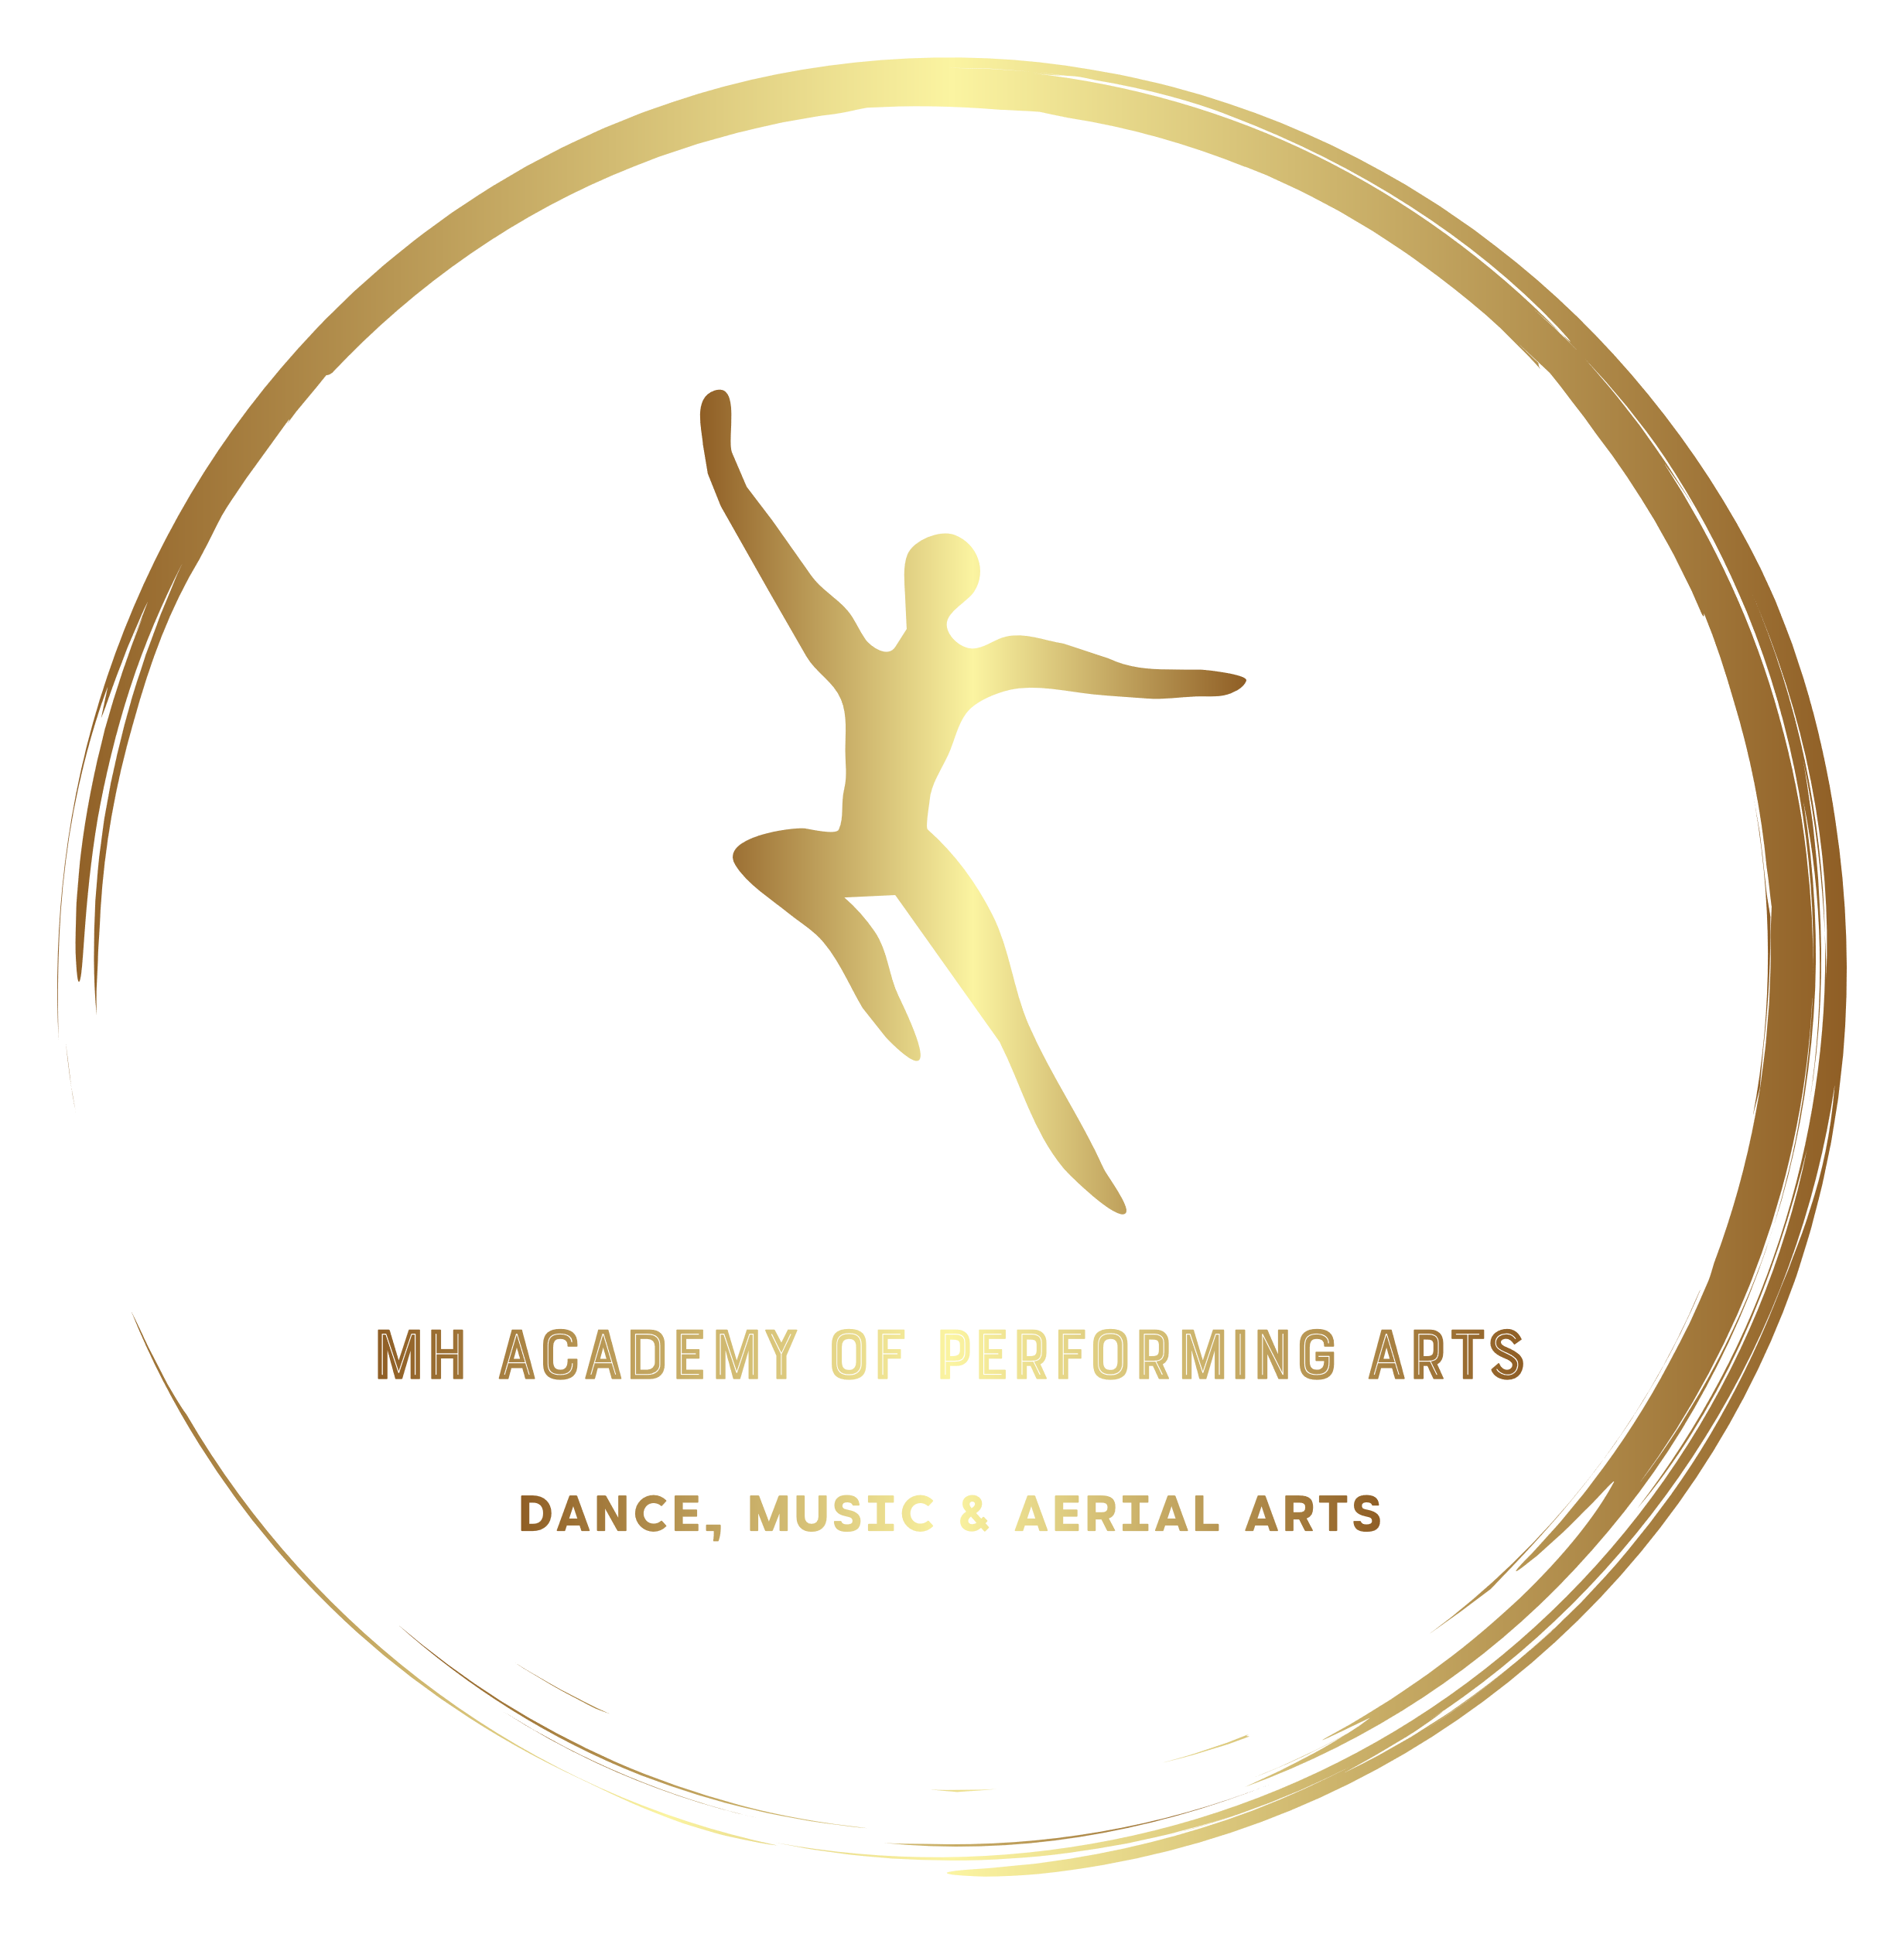

SCHOOL FUNDS POLICY

- School Funds are monies that are held separately to the normal accounts of MH Academy of Performing Arts.
  - These include funds raised from but is not limited to:
- Fund Raising Events
- Government Grants
- Charitable Grants
- Student Organised Events
- Raffles/ Tombola in aid of School
- Lotto Themed Fundraising

  - School Funds must be given to a designated officer who will have control over:
- Providing receipts for all donations
- Keeping a running total of school funds as monies are donated or are withdrawn
- Posting regular updates about how much we have in the school funds
- Banking the monies to its own dedicated account
- Authorising withdrawals from the funds for projects as required

  - The School Funds will be used for:
- Purchasing Costumes for External Cast when required for shows/ competitions
- Purchasing sets for Troupes
- Making up any short fall in company financial obligations
- Purchasing Equipment such as Ballet Bars, Crash Mats amongst other items essential to the safety of the students and continuation of the school.
- Facilitating shortfall in company financial obligations
- Supporting company advertising campaigns where required

  - School Funds will NOT be used for:
- Purchasing School Uniforms for students
- Buying scenery/ props for Soloists/ Duets or Trios
- Buying company stock to be sold for profit

- All donations to the school fund are non-refundable

- The designated officer for School Funds is:
Mark Harrington, MH Academy of Dance, Redhill Family Hub, Redhill Road, Stockton-on-Tees, TS19 9BX.

- Complaints regarding the school fund should in first instance be raised in writing with the Designated Officer who will then carry out a full investigation into the complaint and respond in writing within 28days of the complaint being received. Should more time be required this will be communicated in writing by the designated officer.
Following the investigation, a full response will be provided as to resolve your complaint along with any recommended actions that will be forwarded to the principal.
Should you still have cause for concern following this you can book an appointment with the principal Mark Harrington by submitting a written request with full details of your complaint to: Mark Harrington, Norton Studios School of Dance, Norton Dance Studios, Edgar Street, Norton, TS20 2HG.
All donations to the school fund will be received with the utmost gratitude and we will use all monies raised in the most effective way possible to provide all students with the best possible experience whilst studying with us. If you wish to donate monies to the school fund for a specific purpose please make this clear at the time of donation as the money may be allocated to other things if we are unaware of its unintended purpose.
I confirm that I have seen and agree to the conditions set out by this policy, I understand fully that the designated officer may change at the discretion of the principal and that all deposits to the School Fund are non-refundable.

Signed: …………………………………………………………………………………

Print: …………………………………………………………………………………….

Date: …………………………………………………………………………………….

