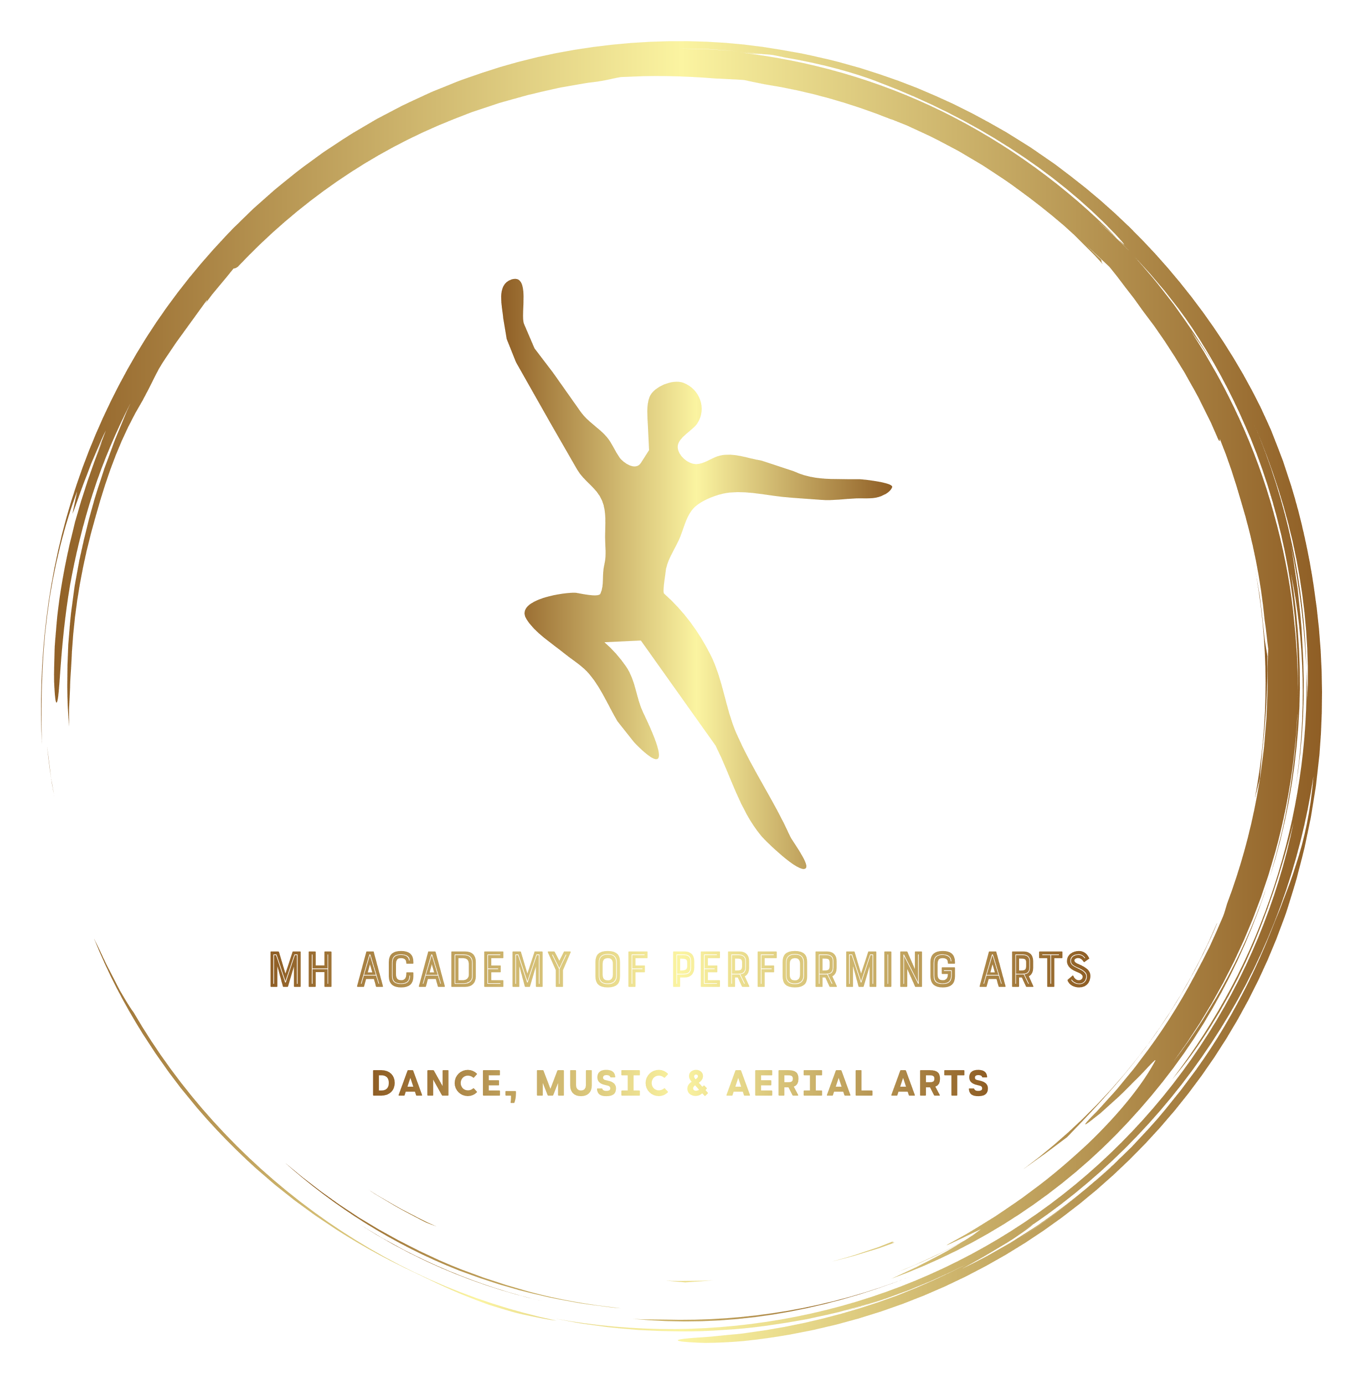

DATA PROTECTION POLICY
Our Privacy Promise:
We Promise to:
- Keep all your personal data safe and secure
- Not to sell your personal information to any third party
- Not to share your personal information without your direct consent.
Collecting your Personal Information
We collect information that is necessary to ensure that we hold the most appropriate and up to date records to ensure each person’s safety and security in line with safeguarding legislation and record keeping.
We ask for this or may obtain access to your personal information when you/ we:
- Enrol as a Student
- Apply for a Position within the company
- Volunteer as a staff member within the company
- Register for Competitions
- Apply for Child Licensing for performances
- Connect with MH Academy via social media
- Provide bank details for payments/ balance transfers
- Subscribe to any newsletter/ article which is published by the school
- Advertise within our programmes
- Completing Accident Forms
The Personal Information We Will Collect
Includes but is not limited to
- Name, Address, Telephone Number, Date of Birth and Email Address
- Details of GP, Medical Conditions and Allergies
- Bank Account Number/ Sort Code (If paying by DD/ Standing Order/ Cheque)
- Credit/ Bank Card Details (If paying by card)
- Records of contact with the company such as e-mail, Direct Messages, Text Messages, Letters
- Details of Designated persons/ Emergency Contact Details
Using Your Personal Information
Your Name and Age may be published in competition programmes/ show programmes which will be sold at events such as Annual Galas, School Musicals/ Pantomimes and competitions.
Your name may also be published on social media for advertising purposes, announcement of competition wins and for promotional material for productions.
Sharing Your Personal Information
Apart from in the circumstances detailed under ‘using your personal information’ your data will not be shared with any third party without your express permission.
Keeping Your Personal Information Safe and Secure
Access to student records is strictly limited to school staff on a need to know basis.
Personal data will be kept for the period of which you attend the school as a Student/ Staff Member plus a period not exceeding 5years.
You reserve the right to request that any personal information stored by the company be destroyed prior to this date by making a request in writing to Mark Harrington, MH Academy of Performing Arts, Red Hill Family Hub, Red Hill Road, Stockton-on-Tees TS19 9BX. Detailing what information, you would like to have removed from our records. You also reserve the right to see/ update these records at any time by making a written request to the above address.
All hard copies of sensitive material are filed away in a locked cupboard so that they are not freely accessible and only the designated officer has the key to access this.
Electronically stored information such as student databases are maintained on a password protected PC which has an active firewall to prevent intrusion.
Please note emails that are not sent via secure server or direct messages via social media are not secure and we cannot be reasonably held accountable for any security breach via these platforms as it is beyond our control.
Designated Officer
The companies designated officer for Data Protection is Mark Harrington, MH Academy of Performing Arts, Red Hill Family Hub, Red Hill Road, Stockton-on-Tees TS19 9BX
All queries/ requests should be made in writing to the designated officer at the provided address.

I confirm that I have seen and agree to the condition set out by this policy, I understand fully in what circumstances personal information may be shared and what data may be stored by the company.

Signed: …………………………………………………………………………………

Print: …………………………………………………………………………………….

Date: …………………………………………………………………………………….

