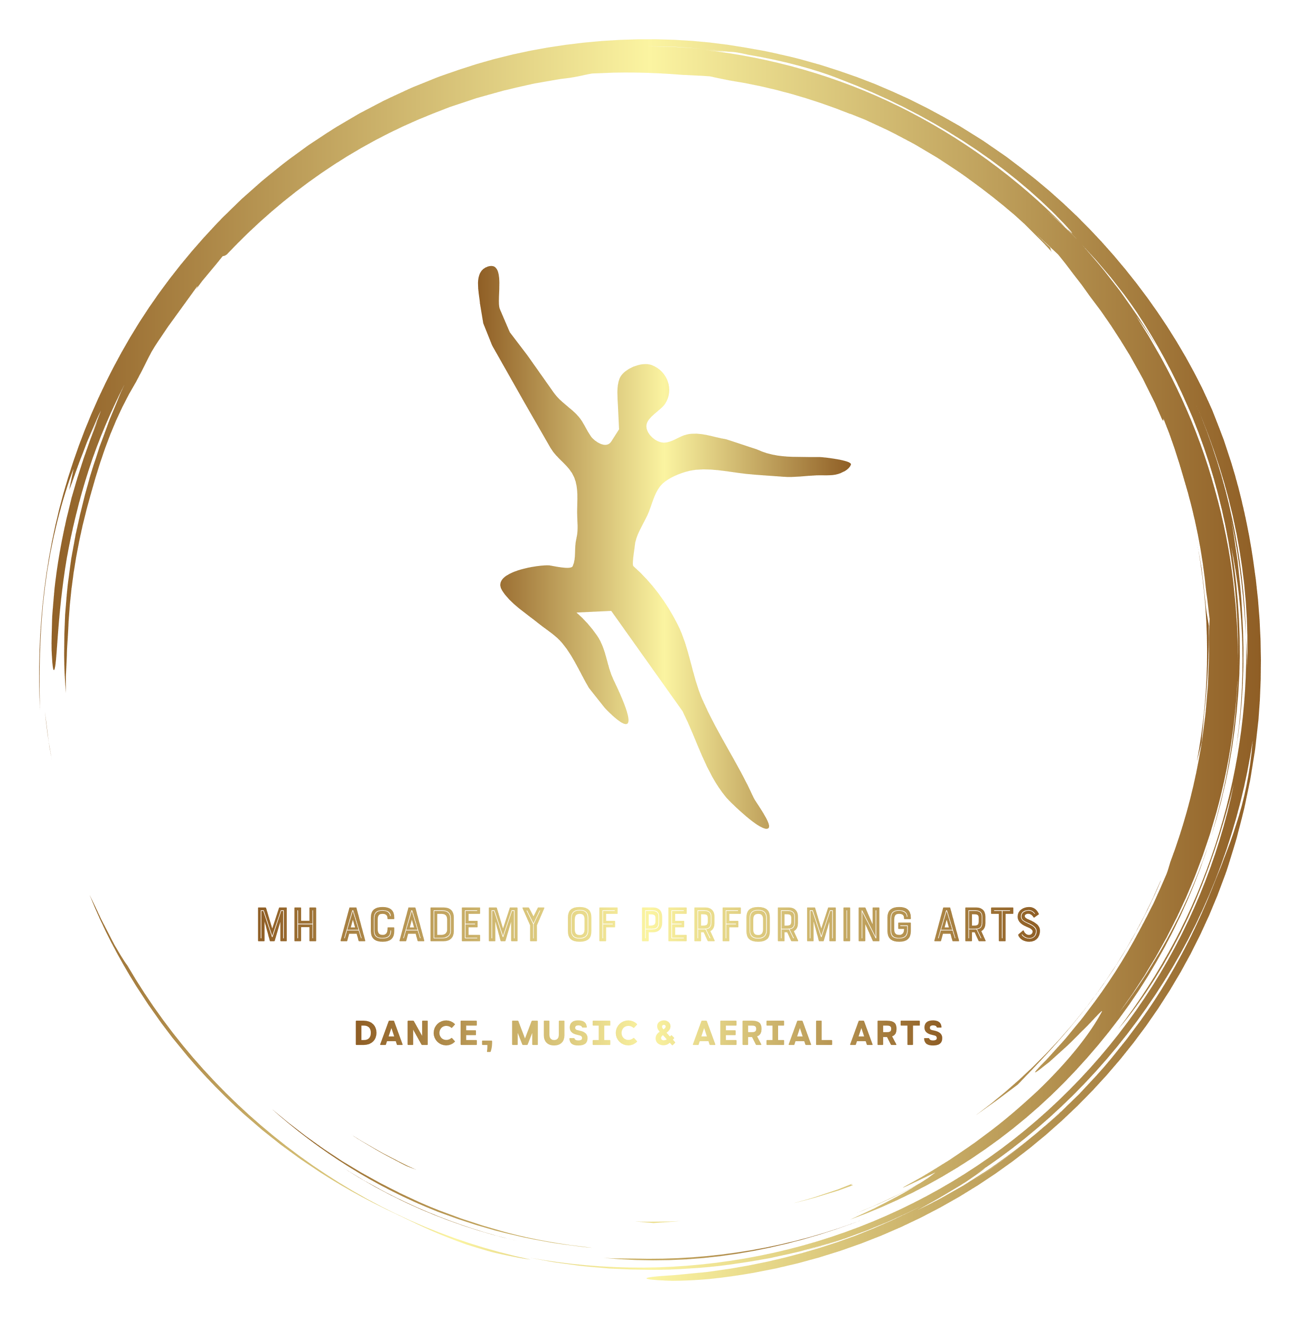

Contents
Page
About Us 3

Timetable 4

Classes Information 6

Exams 8

Competitions 10

Prices 11

Uniform Policy/ Costumes 13

Contact Us 15

About Us
MH Academy of Performing Arts is a local performing arts school specialising in not only dance but all aspects of traditional theatre training and as of 2020 Aerial Arts and Fitness
MH Academy of Performing Arts opened its doors to the public for the first time on 29/04/2018 and welcomed its first members to the start of a long and exciting journey.
Our aim to provide a fun and relaxed atmosphere with a positive approach to the tuition of performing arts in a safe, caring environment.
As a company MH Academy of Performing Arts prides its self on excellence and we have selected all our staff carefully so that we are not just colleagues but a close group of friends that works together seamlessly to provide your child with the best possible experience and theatrical training.
MH Academy of Performing Arts currently provides a selection of dance classes for 6 Age Groups. These are:
- Tots Class (Ages 2-4)
- Infant (School Year Group 1 - 3)
- Junior (School Year Group 4 - 6) - Intermediates (School Year Group 7 - 8)
- Seniors (School Year Group 9 – Age 18)
- Adults (ages 18+)
Alongside our dance classes we also provide Singing and Piano tuition from our highly experienced staff who have an excellent track record with exam and competition entries. These sessions are one to one and priced in line with our private lesson fees. In addition to this as our music student numbers grow we aim to establish a Choir for Competition’s, Shows and Charity work.
We are now also running fitness lessons for adults, specifically Zumba With Miss Catherine and Pole Fitness with Mark
No previous knowledge or experience is required as all levels will be catered for, whilst meeting the individual needs of each student.
We believe that confidence is the key to success, no matter what age group you belong too. Therefore, all the material has been carefully chosen to be at a suitable level for the ages. We also believe that showcasing each individual student’s talent is also vital regardless of their ability and therefore we ensure that each student will always have a chance to perform in each production.
In addition to our high standard of delivery of the subject areas at Norton Studios we strive to increase the autonomy of each of our student by offering them chance to have actual input into productions, opportunity to get creative and choreograph their own dances, and even take exams through carefully selected awarding bodies that can even award students UCAS points for their university applications.
Please see our website for our most up to date timetable.
As student numbers grow it is our intention to implement an extended time table that will provide a wide variety of classes and multiple age groups to best accommodate student needs.
Information on future classes can be discussed with any of our teaching staff who will be happy to provide information on our future classes and time tables.
This section will be updated as we expand the time table and updated copies can be requested from admin at any time.

Classes Information

Tots Classes
Our Tots Class is aimed for children under the age of 5 who will have a vast variety of tuition ranging from learning group songs to perform in shows as a choir and basic dance movement classes including Ballet, Tap and Jazz to prepare them for the next step into our infant age group and associated classes.

These Classes will also consist of IDTA Preparatory Syllabus work so that students are confident and have the basic techniques for when they progress.

Tots Class is now also expanding into our new Princess Classes and Tots Acrobatics is coming soon!

Acrobatics Classes
Acro is designed to improve flexibility and strength by working on students abilities to perform “Gymnastic Style Tricks” and balances. These skills will then be adapted into choreography for Acro Solos and also Troupes, we also aim to implement Exam Sessions into our Acro Classes

IDTA Classes
Our IDTA Classes are syllabus based in which your child will be provided with the most up to date techniques in classical Ballet, Jazz and Tap styles.
All Students will start at the appropriate Grade and work their way through the syllabus as per association Rules. As exams are completed we will provide the next grade to students and continue the previous grade class for students who are not yet ready to progress to the next stage so that all student’s complete exams in their own time when they feel confident and not pressured to do so.

Duets & Trios
A Competition class where students will be given the opportunity to dance with a partner in any of the styles we currently teach, they will then perform in competitions and shows with their partners with the choreography they learn in these lessons.

Troupes Classes
Troupes are our main classes for competitive dance and shows. These lessons will be spent learning new choreography, and dance styles to train the students to a standard where they are ready to perform publicly.
Zumba
A fun adult fitness class ran twice weekly with Miss Catherine this class is designed to get your heart pumping to feel good music and for all to have a great time whilst getting a good work out with our new party fitness dance class.

Pole Fitness
Our newest addition to our repertoire of classes, pole fitness is a very demanding art form which pushes your body to the limit mentally as well as physically this unique for of exercise works every muscle in your body and you will leave class feeling like you have conquered a mountain. This class comes highly recommended from all who attend and say their accomplishments give them such a feeling of pride they which they had done this years ago!

Private Tuition
Our private tuition sessions will be tailored to suit your needs, we will be offering private lessons in all areas (Dancing, Singing, Drama) These are particularly beneficial if you are wanting to enter Competitions as a Soloist/ Duet/ Trio etc.

Please Note to enter Solos into a competition you MUST have one of these classes

If you want to book a Private Tuition slot please contact your teacher or Mark on 07960188773, alternatively you can send a message through Facebook page.

Singing & Piano
These are one to one classes with one of our music department staff who will work on your abilities as a performer be it improving the quality and the sound of your voice, to learning pieces of music to play on piano.
These classes are designed to boost confidence and work to each individual students ability. Exams are also available in these genres through one of our awarding bodies, LCM and RSL (see below for more detail)

Taylor Made Sessions
If you have a group of people who want to have their own sessions delivered such as line dancing, your own vocal group or drama society, please feel free to get in touch as this can be arranged as per your request, we do however ask that for these sessions you have a minimum of 10 students and will be chargeable at a rate of £4.00 per person.
Examinations!

MH Academy of Performing Arts will be providing excellent vocational qualifications through tailor made syllabus’ which not only allow your ability’s as a performer to develop but you can also obtain valuable UCAS points for them University Applications or even become a qualified teacher.

These Qualifications will be offered in all areas and can be assessed in group situations as well as individually depending on the exam entered. Practical and Theoretical Training will be provided mostly through group classes however Private Tuition may be required for certain exams such as Vocal Performance Exams.

IDTA:

At the heart of dance
Training the next generation of passionate and expert dance teachers and their students

As a leading dance qualifications body and membership association for professional dance teachers, with over 6000 members in over 55 countries, we define standards across the widest variety of dance forms, examine performance for both professionals and non-professionals of all ages, develop the skills and professional practice of our members and promote the love of dance across a dynamic, global community
London College of Music:
London College of Music (LCM) is the largest specialist music and performing arts institution in the UK.

LCM Offer an impressive range of innovative courses, respected worldwide and delivered with creativity and passion.

LCM have been described as providing ground-breaking courses that are respected worldwide and are taught by practising industry experts who love what they do. With affiliations from international sources to ensure that their content is always at the precipice of modern music, be it theatre, classic or even pop music.
UCAS Points are also awarded when completing grades 6+, Students will also be able to achieve higher Diplomas in their Vocal Theory and Performance Exams which can qualify students as teachers.
Rock School Awards Ltd:
Rock school began offering exams in the summer of 1991, making it the world’s first graded exam syllabus for popular music.
With grade exams now available in 9 different disciplines, each syllabus is developed with the care, skill and expertise to ensure that every addition is creative, innovative and industry relevant; with the objective to provide access to music education for the many, not the few.
After successfully developing the market domestically in the UK, the company began expanding its operations into the international marketplace. Beginning with a handful of test venues many years ago - RSL now delivers exams in over 40 countries worldwide, across 6 different continents.

UCAS Points are also awarded when completing grades 6+, Students will also be able to achieve higher Diplomas in their Vocal Theory and Performance Exams which can qualify students as teachers.

Additional information regarding our awarding bodies and what you will study with each of them can be requested from any of our teaching staff at your convenience.

Competitions!

At MH Academy of Performing Arts we will be competing against other Dancing Schools in Local Competitions!

We intend on doing 4 Dancing Competitions a Year which will include:

- Elwick Academy Whit Week Stage Festival
- Karen Liddle Stage Festival (October Half Term)
- Easter Stage Festival
- Our very own dance festival which we are expecting to launch February 2022

This is in addition to championships and Miss Dance/ Master Dance of Great Brittan which are separate entities and will be discussed when we feel that students are ready for these competitions.

Singing/ Music Competitions and Festivals are to be arranged by the head of Music as festival details are announced however these will include but will not be limited to.

- Stockton Music Festival
- Darlington Music Festival

Students are not required to enter these competitions as soloists however it is encouraged and if you are a part of a Troupe/ Choir participation in competitions is expected as these will be showcased when competing against other schools and absences will have an effect on the overall performance.

The Money Part

There are various options available for payment depending on the student’s requirements. Please see below a list of the options available.

Tots:
Dancin’ Tots: £6.00
Princes & Princess Class: £4.00
Tots Acrobatics: £4.00
Infants, Juniors, Seniors & Adult Classes:
£4.00per Lesson
All Classes Excluding Premium Classes: £80.00 per month
Rehearsals:
These are charged £2.00 per rehearsal. (Unless paying monthly fees.)
Premium Classes:
Pole Fitness: 1 Hour £7.00
Private Tuition: ½ Hour: £12.00
1 Hour: £20.00
If you choose to do so you can split a 1-hour lesson between Dancing and Singing.
The only exception to lessons contained in monthly fees are Premium Classes as due to equipment costs, membership fees, specialist area or they are taught on a 1 to 1 basis.
All fees are billed monthly in advance and the full invoice must be paid in full by the 10th of the coming month. Private Lessons are exempt from this.
Additional Discounts for paying set monthly fees: £80.00 per Month with discounts and holidays applied saving £88.00 (minimum) annually without the additional class fee reductions.

Payment Methods:

Classes can be paid for in a variety of different ways including;

Cash, Bank Transfer, Standing Order or Card Payment

Lessons that are not attended without sufficient prior notice will not be refunded and are still chargeable. 48 Hours MUST be given for cancellation of Private Lessons or they are still chargeable Monthly Fees are none refundable and must be paid via Standing Order on the agreed date every month.
Payments that are not made by the 10th of the month will result in your invoice receiving a £10.00 late payment fee unless previously discussed with the principle only.
Failure to pay for classes on a regular basis may have result in your child not being allowed to take part in classes until all fees are paid up to date.
(This is a last resort as this is something we would never want to do, Mark is always available to discuss any issues that may affect your ability to pay school fees.)

Uniform Policy
MH Academy of Performing Arts operates on a uniform policy and from the start of enrolment all students will be expected to wear a uniform. This is for health and safety reasons and must be adhered to at all times. Any student not wearing the correct uniform may not be able to take part in their lesson.

We appreciate that everything costs money therefore we will do our best to keep the costs down.

Uniform – Young People

Tots/ Infants – Blue Skirted Leotard, White Ballet Tights and Ballet Shoes. Tap Shoes should be elasticated and white.

Juniors - Pale Blue Leotard, White Ballet Tights and Black Ballet Shoes. Tap Shoes should be elasticated and black.

Intermediates/ Seniors – Plain Black Leggings, Crop Top/ Appropriate T-shirts. Students will require Black Ballet Shoes and Black Tap Shoes for classes.

Uniform – Adults

Sensible clothing with footwear appropriate for the class you are taking part in

Uniform – Sublimated Design
We also have Sublimation Design School Uniforms which are required for competitions. These however can also be worn for classes and the jackets can be used for day to day wear.

Please see your teacher to place an order for this.

These are compulsory for competition students.

Hair
Must be tied up and out of the students face this is for health and safety reasons

Costumes

It is our intention to do two shows a year which will include a Winter Gala and a Summer Pantomime. As former students of different dance schools we are aware that the cost of these costumes can build up quite quickly especially when also looking at costumes for Competitions and Troupes etc.

We will endeavor to keep the cost of these costumes down to an absolute minimum by buying direct from suppliers and using our own dress/ costume makers to keep the price as low as possible.

We will also make sure that you are informed of costs relating to this as early as possible and offer saving plans/ pay weekly offers to facilitate putting money to one side to cover these costs. In addition to this where appropriate Norton Studios will facilitate the purchase of certain costumes and props.

All our school uniform items are available on our Online Store:

nst.mydancestore.co.uk

This website can also be used to purchase costumes and will be regularly updated as required by the principle of the school.

All items are reasonably priced and are subject to a small delivery fee which is charged directly by the website.

Contact Information
If you would like any further information or would like to book your or your child’s place then you can contact us on;

Mark: 07960188773

Or e-mail us on:
Mark@MHAcademy.co.uk
Website: www.mhacademy.co.uk
You can now also find us on Facebook just search @NortonStudios1

Please note this welcome pack will be continuously revised and updated to suit the needs of business, information is correct at the time of publishing.

